Last Scottish Copy Policy – Workflow Guidance

Background
Following the launch of the Last Scottish Copy Policy (LSCP) at the Collections and Metadata Group (CMG) Conference in March 2020, a pilot project was established to determine the workflow requirements to support the implementation of the policy across SCURL member institutions. Three institutions that had planned significant deaccessioning exercises over the summer volunteered to participate in the pilot. These were: the University of St Andrews, the University of Strathclyde and the University of the West of Scotland.
Two members of the pilot group met after the summer deaccessioning exercises had taken place. This meeting led to the creation of a draft workflow, which was then reviewed by the other pilot participant and presented to the Collections and Metadata Group at its September meeting. The whole pilot group then met in October to discuss revisions considering feedback from CMG members.

Summary of the Proposed Workflow
The purpose of the workflow document is to provide a clear route to implementing the policy within SCURL member libraries. The workflow is intended to simplify the policy and present a workable solution for library staff.
There are three main stages in the workflow:

Identifying Material as Scottish
The LSCP states that a copy should be retained within Scotland of Sottish material in any language including material:
a. published in Scotland;
b. published outside Scotland by Scots;
c. about Scots;
d. relating to Scotland;
e. relating to any aspect of Scottish life and culture;
f. about individual Scots.
The workflow asks that staff review materials identified through deaccessioning checks, with a view to identifying material in any of the above categories. It is recognised that some categories will be more difficult to spot than others. For example, unless an author is very well-known, it is unlikely that staff performing shelf checks will be able to identify them as Scottish. On the other hand, material relating to Scotland, or any aspect of Scottish life and culture will likely be more easily identified. It is recognised that libraries do not have the capacity to investigate every title earmarked for deaccessioning, and that some materials meeting the above criteria will be missed.

Identifying Potential Last Copies
Once an item has been identified as Scottish, the next step is to find out about holdings elsewhere. This can be done using the Jisc Library Hub Compare tool. Compare is available to all Jisc members so libraries that have not contributed to the NBK database will still be able to use the tool.

Offering the Last Scottish Copy to a Partner Institution
A short online form will be hosted on the SCURL website for libraries to enter details of material for offer across the network. The SCURL Executive Officer will review submissions via this form and circulate details across SCURL member libraries via existing mailing lists. It is anticipated that the National Library of Scotland will have a strong interest in materials identified through this process.
The library holding the material on offer will then liaise directly with any libraries interested in receiving the material, concluding any agreements regarding transportation etc through mutual agreement.

Implementing the Policy: Case Studies
The case studies below were created by the three pilot libraries and outline suggested approaches to implementing the policy. These examples are intended as guidance only, recognising that each SCURL member library will have specific policies and processes to suit the operational context.

University of St Andrews
This case study highlights the methodology St Andrews are applying to identify possible last Scottish copies as part of a larger de-duplication project across our holdings. It uses a combination of manual data checking on Excel and the Jisc Compare tools.
- SQL data for matching titles is pulled from Sierra LMS. The data from the system includes classmark, title, edition, imprint information, location and usage.
- As the data is in Excel format, use ‘Find and Replace’ option to undertake basic searches to quickly identify possible Scottish content e.g.
- ‘Scot’ anywhere in the table
- Key Scottish locations e.g., ‘Edinburgh’, ‘Glasgow’ in the Imprint column
- Focus on any titles which have specific LC classification for Scotland e.g., DA750-DA890
- If in doubt check the catalogue record for subject headings information e.g., geographic subdivisions
- If in doubt check the physical book for further clues

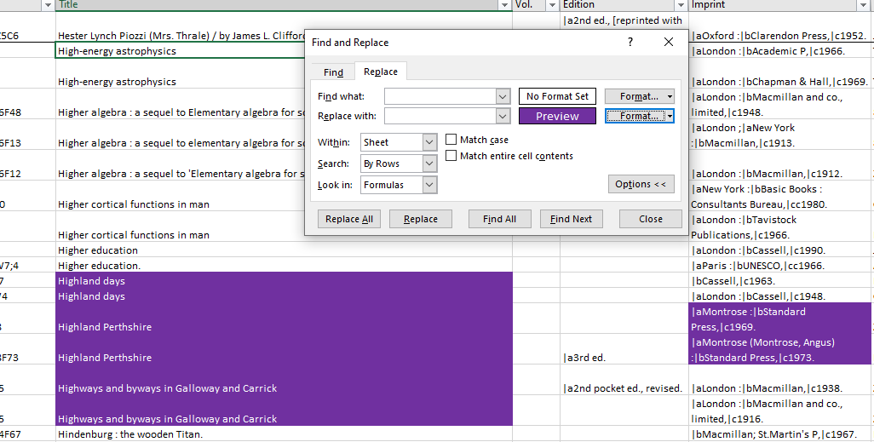
- Sort table by colour to pull these titles together and then compile local record numbers in either a text or CSV file and upload to Jisc Compare using batch search/local record no. and Scotland as region (if using record no. be aware that you may need to add a dot at the start e.g. .b12167204)
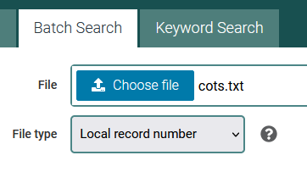

- Look at the data more closely using the Analyse by library or Analyse by collection to look at the data more closely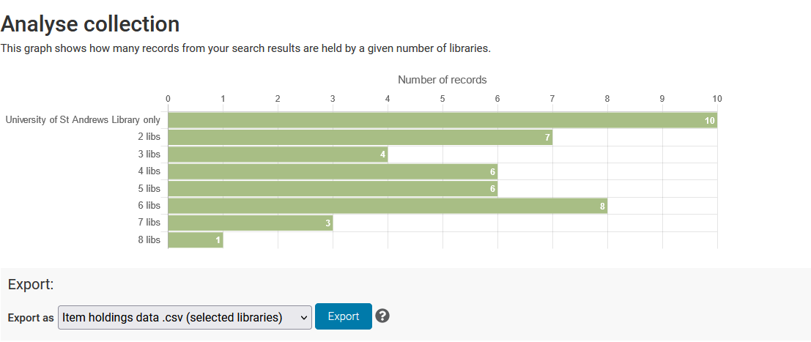 and aid decision making

- Any titles which are held by 2 libraries or less can be identified and checked to ensure they meet the criteria for the last Scottish copy policy.
- Should STA be the only holding location consider whether to retain
- If yes, apply retention status
- If no, offer to SCURL partner institutions

This can be an effective approach for quickly highlighting any obvious Scottish content. As a rule, the team are expected to keep an eye out for other pertinent clues during the weeding exercise, helping mitigate the potential loss of Scottish material.

Using Jisc Compare to batch search Author/subject/Title
It is also worth bearing in mind that Jisc Compare can enable batch searches by subject/title/author: limiting the region to Scotland is another way to provide an overview of Scottish content, creating a handy snapshot of those titles which may be at risk. Libraries could possibly use this method to preserve local content and apply a SCURL retention status to relevant catalogue records.
For example: Keyword search Scotland, region limited to Scotland

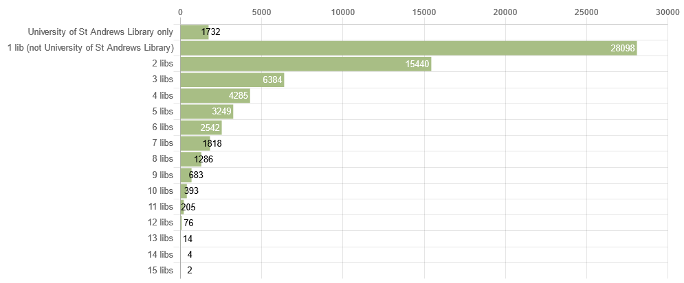
Or Fife as a keyword, region limited to Scotland
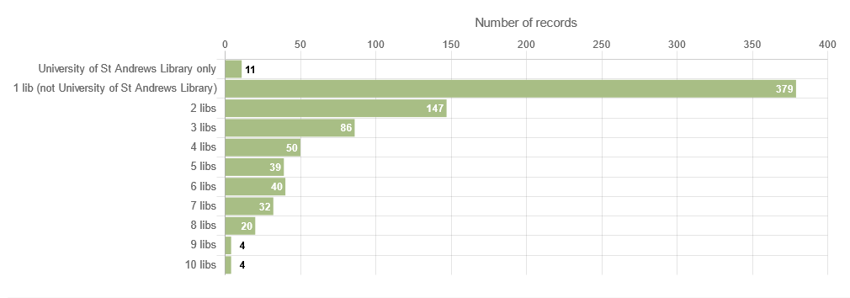

University of Strathclyde
This case study describes how the Last Scottish Copy check is carried out as part of the ongoing stock review programme at Strathclyde. The Library Hub Compare tool is used here as a quick and easy initial check to narrow down the list, but some manual searching is still required to ascertain whether an item is definitely eligible for the LSC Policy.
- Generate an Alma Analytics report of all items (within a given location or call number range) added to the collection more than 10 years ago that have not been borrowed for at least 10 years. Export to Excel (other spreadsheet applications are available!).
- Copy local record numbers (i.e. Alma MMS IDs) from this report and paste them into a text file.
- Log in to Library Hub Compare, go to the Batch Search tab, upload the text file and choose ‘Local record number’ as the file type (N.B. Compare will also allow you to batch search using standard numbers such as ISBNs, or with title phrases). Under ‘Regions’ restrict the search to Scotland, and choose to deduplicate records with a shared ISBN.
- Once the search has completed, export the CSV file of item holdings data for selected libraries.
- In Excel, open the report generated in step 1 and the file exported in step 4. Use a LOOKUP or VLOOKUP function to show in the report how many Scottish institutions in the NBK hold a copy of each item. Where Strathclyde is the only holding library identified, flag this item for a further ‘Last Scottish Copy’ check.
- Report is then sent to relevant colleagues to decide which items should be retained and which considered for withdrawal.
- We can now create a list of items to be withdrawn which were identified in step 5 as potential Last Scottish copies. Items in this list should be assessed individually, and any that do not qualify as ‘Scottish’ according to the LSC Policy can be removed.
- Individual manual searches should be carried out for all items remaining on the list. The Library Hub Compare tool is a quick but sometimes imprecise method of searching for matching copies. Searches should include Library Hub Discover, National Library of Scotland, any Scottish HE libraries not on the Library Hub, and finally any other SCURL members.
- Any items which are definitely eligible for the LSC Policy should be offered to libraries according to section 3 below, ‘Offering the Last Scottish Copy to a Partner Institution’.

University of the West of Scotland Case Study
Items for potential withdrawal are identified within a specific Dewey range using an Alma analytics file reviewed for parameters including; last loan date, acquisition date, publication date, edition and inclusion on reading lists.
- Previous editions of textbooks are withdrawn without reference to the policy. (It is assumed that items used as textbooks are unlikely to be rare).
- Monographs are identified and flagged on a spreadsheet for potential withdrawal.
- As part of the withdrawal process, where the item is the last copy of a title in the library, staff are looking for a number of elements that might mean the resource should be retained. As one of these elements, individual items are picked out that potentially meet Last Scottish Copy criteria (e.g. through title reference or known author). ‘Older’ resources (pre-war or older) would be checked more carefully, including publication / printing place in Scotland and possible local authors.
- Identified items are put aside to be checked against Library Hub Compare to see which other libraries hold the resource. As this is not a particularly common occurrence, items are usually checked individually.
- Where fewer than 3 other libraries are identified, these items would be re-considered for retention. Where retention is not required these would be offered out to other institutions.

Next Steps
The workflow will be circulated from January 2022. The pilot phase will be extended until July 2022 to allow the working group to take feedback from early adopters, and to adjust the workflow accordingly. The final version of the workflow will be published in September 2022.
Directors are asked to promote details to relevant staff teams. SCURL will provide ongoing admin support for the policy.

